[Léiritheoir Millson Tueker](https://ddb.ac/characters/68068881/YgrJ9S)

Etymology: Producer (Irish) | Honey-son (Irish) | ~~Priar &~~ Tuck

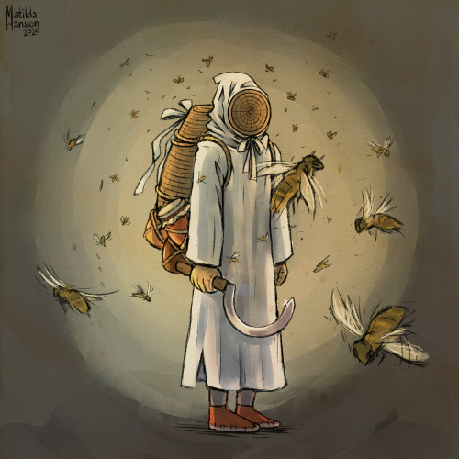

*“bare the brew threw to thee, the beer I drew for all of ye.”*

~ [**A.I Root**](https://en.wikipedia.org/wiki/Amos_Root), Gleanings with Bee culture, January 1773.

Translation: Take the beer I made for you.

Mead would be more accurate:

*“bare the brew made for thee, this mead I drew for all of ye.”*

~ **Léiritheoir Millson Tueker**: Storybook Glen - merry making festival, 1778.

# Facts:

**Name:**  Léiritheoir Millson Tueker

**Occupation:** Beekeeper, recluse

# Description:

## Personality:

Not many words penetrate her skin and suit, and if it did she’d soothe it with honey.

Sweet, like honey.

## Physical:

Like all of the things in her life. Léiritheoir reminds people, vaguely, of honey. With her golden-brown hair, fair skin - covered in stings, soothed by honey and honey-coloured eyes.

Although she is seldom seen without her bee suit - specially designed to keep bees IN rather than out, allowing her to never part with them.

Léiritheoir uses honey to soothe the stings she feels every day, and as such smells sweet and flowery.

## Interests:

* Avid reader. Favourites include:

Glennings with Bee Culture,

Glennings with Beekeeping; A sequel to the first,

ABCs for Bees, and

The Idle Beekeeper; The Low-effort, Natural Way to Raise Bees.

* Enjoys going to farmers’ markets.
* Loves their bees
* Makes mead and honey/wax based products, like soap and perfume.
* Beekeeper/Botanist?
* Eccentric, enjoyer of good times. Slightly tipsy most of the time due to the need for “mead testing.”
* Long walks in meadows with their bees.
* Cooking with honey-based products.
* Weaving skeps for bees.
* Talking about bees - with flowery language.

# Connections

Mother’s first husband Gorum.

**Mother** Websteris sweet, like honey. Always tucked her in before bed.

**Father**, son of Ms. Maisy, the miller, is a beekeeper, took over after father was killed in a freak milling accident, the mill was repossessed and the mother married her landlord.

Now estranged [**Husband**](https://lightprkdraws.tumblr.com/post/645559036229599232/a-plague-doctor-dancing-with-their-medieval) is a doctor.

Three brothers - **Abottoir Gorum** - Butcher, **Doborious** “Dobo'' - baker, **Glim** - candlestick maker.

**Hero** to Rebecca-Ann Alderious.

Receives majority of jobs from the **Keepers** (Adventuring guild).

Angel of God, my guardian dear, to whom God's love commits me here, ever this day be at my side to light and guard, to rule and guide. Amen.

May you be forever Gastered in the depths of Kola Su-Bore (whole-are Sue-vore).

Be never assimilated.

Forever hold with Ulster.

Honey Priar, Léiritheoir Millson Tuekeriail Leitrim Sea Ash Pedigree Trout Gelderstone Trout Galway Rock Line Corree Phin Mahon Trout Magee Trout Maidenfool Leitrim Teal Gelderstone Trout Seam Leitrim Crick Gelderstone Trout Fernhill Leit

# Equipment:

**Sickle**

**Mace/Honey Dripper:**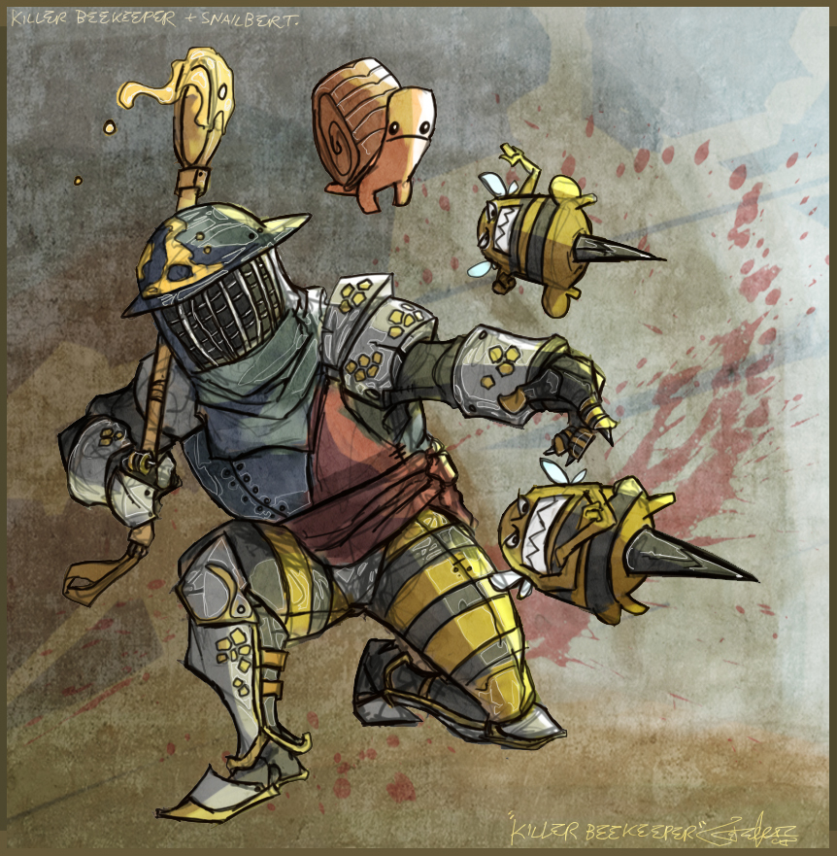

**Stick?**